Game Design Document

Fill up the following document

1. Write the title of your project.

Jetskie

1. What is the goal of the game?

The jet must land on the moon at the end of the game.

The jet carrys astronuets ,u must save there life’s.

1. Write a brief story of your game.

The astronuets want to go to the moon for some research,but it’s a dangerous day that,while on the way there will be attack from meteors,alieanships.On the top of the screen there will be the total life that u have .There will be some rare stars that will give u and ur crew the life’s.The score of this game will be the distance coverd by the jet with astronuets….

1. Which are the playing characters of this game?

* Playing characters are the ones who respond to the user based on the input from the user.
* Cars, monkeys, dinos, wizards, etc., are the playing characters in the game.

|  |  |  |
| --- | --- | --- |
| Number | Character Name | What can this character do? |
| 1 | Jet | Move with the arrow keys. |
| 2 |  | Press “w” for shooting the enemy. |
| 3 |  |  |
| 4 |  |  |
| 5 |  |  |
| 6 |  |  |
| 7 |  |  |
| 8 |  |  |

1. Which are the Non-Playing Characters of this game?

* Non-Playing characters are the ones that don't have an action or behavior when the user interacts with the game.
* Hurdles, stones, bananas, coins, etc., are non-playing characters in the game.

|  |  |  |
| --- | --- | --- |
| Number | Character Name | What can this character do? |
| 1 | meteour | This is an obstacle which attacks the jet.. |
| 2 | Enemy jet | This is also an obstacle which attacks the jet by shooting on the jet.. |
| 3 | Stars | The stars are obstacles that give u more life.. |
| 4 |  |  |
| 5 |  |  |
| 6 |  |  |
| 7 |  |  |
| 8 |  |  |

Draw your imagination of this game. What does this game look like?

* Draw the game either on your computer or on paper.
* Add images of the game scenes to show each of the playing and non-playing characters at least once.

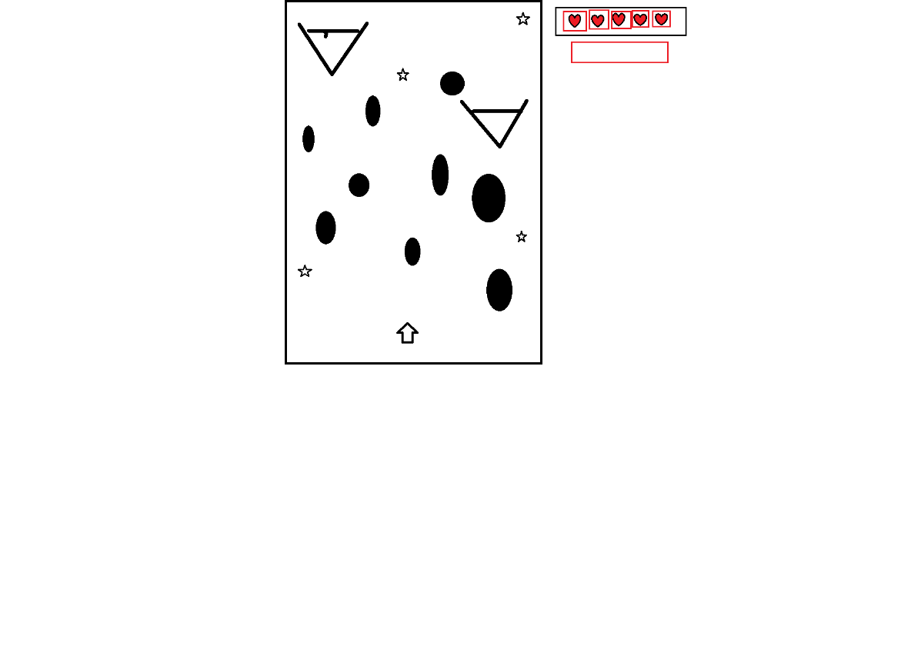

How do you plan to make your game engaging?

There will be different types of levels for making this game more engaging.